ITN (Version 7.00) Final PT Skills Assessment (PTSA) Exam Answers

Topology
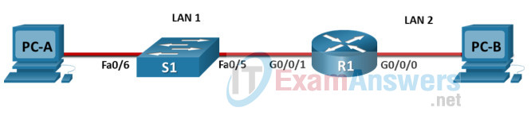
ITN Final PT Skills Assessment (PTSA)

Device Names Table
You will receive one of three possible scenarios. In order to use the logical topology diagram that is provided with the instructions, use the device names in the Device Names Table.
Topology Diagram Name | Your Scenario Name
R1 | R1
S1 | S1
PC-A | PC-A
PC-B | PC-B

Addressing Requirements Table
Item | Requirements
Network Address | 192.168.10.0/24
LAN 1 subnet host requirements | 100
LAN 2 subnet host requirements | 50
R1 G0/0/1 | First host address in LAN 1 subnet
R1 G0/0/0 | First host address in LAN 2 subnet
S1 SVI | Second host address in LAN 1 subnet
PC-A | Last host address in LAN 1 subnet
PC-B | Last host address in LAN 2 subnet

ITN Final PT Skills Assessment (PTSA)
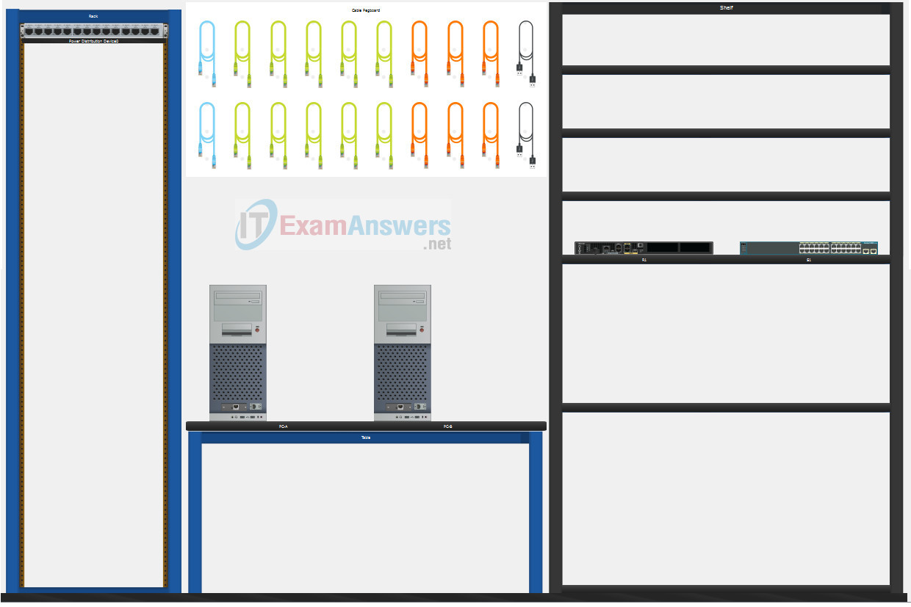
A few things to keep in mind while completing this activity:
- Do not use the browser Back button or close or reload any exam windows during the exam.
- Do not close Packet Tracer when you are done. It will close automatically.
- Click the Submit Assessment button in the browser window to submit your work.

Assessment Objectives
- Part 1: Build the Network
- Part 2: Develop an IP Addressing Scheme
- Part 3: Configure Basic Device Settings
- Part 4: Configure Security Settings on R1 and S1
- Part 5: Configure the Hosts and Verify Connectivity

Instructions
In this assessment you will configure the R1 router and S1 switch, as you have done in the activities in this course. You will also connect two PCs using a switch and a router that are in the main wiring closet. You will subnet the 192.168.10.0/24 network to provide IPv4 addresses for two subnets that will support the required number of hosts. The larger subnet (LAN 1) requires 100 hosts and the smaller subnet (LAN 2) requires 50 hosts.

Part 1: Build the Network
a. Build the network according to the logical topology by placing the required equipment in the wiring closet equipment rack.
b. Cable the network devices in the closet as shown in the topology diagram.
c. Connect the hosts as shown in the topology diagram.

Part 2: Develop an IP Addressing Scheme
In this part of the assessment, you will develop an IP addressing scheme. You will subnet an IPv4 network to create two subnets with the required number of hosts. You will also subnet an IPv6 network. You will then assign the addresses according to the requirements below.
Work with the following information:
- IPv4 Network: 192.168.10.0/24
- Required number of hosts in IPv4 LAN 1: 100
- Required number of hosts in IPv4 LAN 2: 50
a. Record your subnet assignments according to the following requirements.
1) Assign the first IPv4 address of each subnet to a router interface
- LAN 1 is hosted on R1 G0/0/1
- LAN 2 is hosted on R1 G0/0/0
2) Assign the last IPv4 address of each subnet to the PC NIC.
3) Assign the second IPv4 address of LAN 1 to S1 SVI.

Part 3: Configure Basic Device Settings
Network devices must be configured over a direct console connection. Connectivity between the hosts should be established.

Step 1: Configure Basic Settings
a. Disable DNS lookup on R1 and S1
b. Configure router hostname using the name R1.
c. Configure switch hostname using the name S1.
d. Configure an appropriate banner on R1 and S1.
e. Allow console logins with the password C@nsPassw!

Step 2: Configure Interfaces
a. Configure R1 G0/0/0 and G0/0/1 interfaces using the addressing from the previous part of this assessment:
- Interface description
- IPv4 address / subnet mask
b. Configure the S1 VLAN 1 SVI interface using the addressing from the previous part of this assessment:
- Interface description
- IPv4 address / subnet mask
- The switch should be reachable from devices on other networks.

Part 4: Configure Security Settings on R1 and S1

Step 1: Configure enhanced password security
a. Configure DontTellAnyone as the encrypted privileged EXEC password
b. Encrypt all plaintext passwords
c. Set minimum password length to 10 on R1.

Step 2: Configure SSH on R1 and S1
a. Configure netsec.com as the domain name
b. Configure a local user netadmin with the secret password Ci$co12345
c. Set login on vty lines to use local database.
d. Configure the vty lines to accept SSH access only.
e. Generate an RSA crypto key using 1024 bits modulus.

Step 3: Secure switch ports on S1
a. Shut down all unused ports on S1.
b. Enter descriptions for all unused switch ports to indicate that they are intentionally shutdown.

Part 5: Configure the Hosts and Verify Connectivity
Configure both hosts with the IPv4 addresses that were assigned in Part 2 of this assessment.
ID: 011

Answers Key

Part 1: Build the Network
Placing Switch S1 and Router R1 to wiring closet equipment rack.
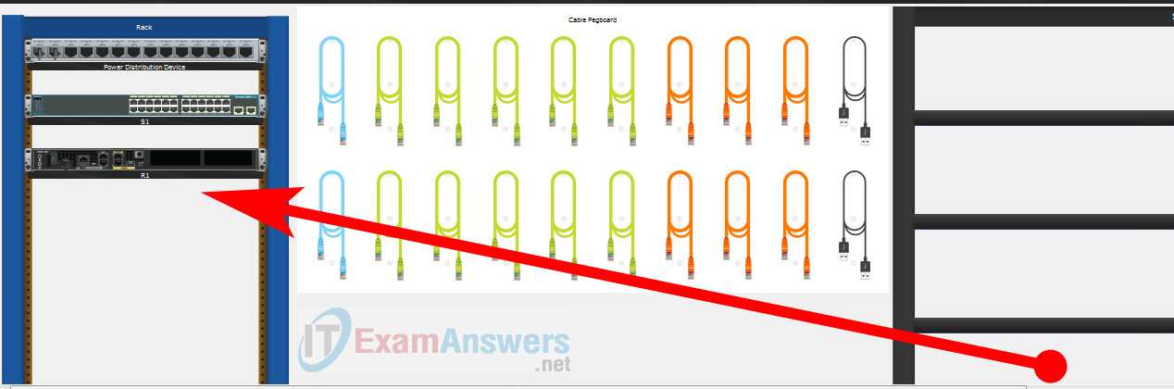
Using Copper Straight-Through cable to connect PC-A (FastEthernet0 port) and S1 (FastEthernet0/6 port)
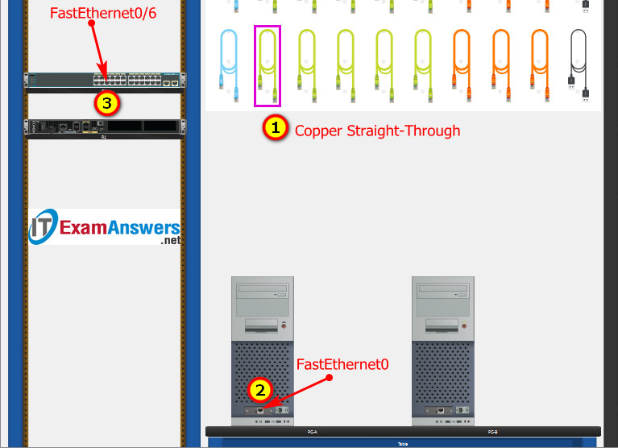
Same as above, using Copper Straight-Through cable to connect all devices as shown in the topology diagram.
ITN Final PT Skills Assessment (PTSA)
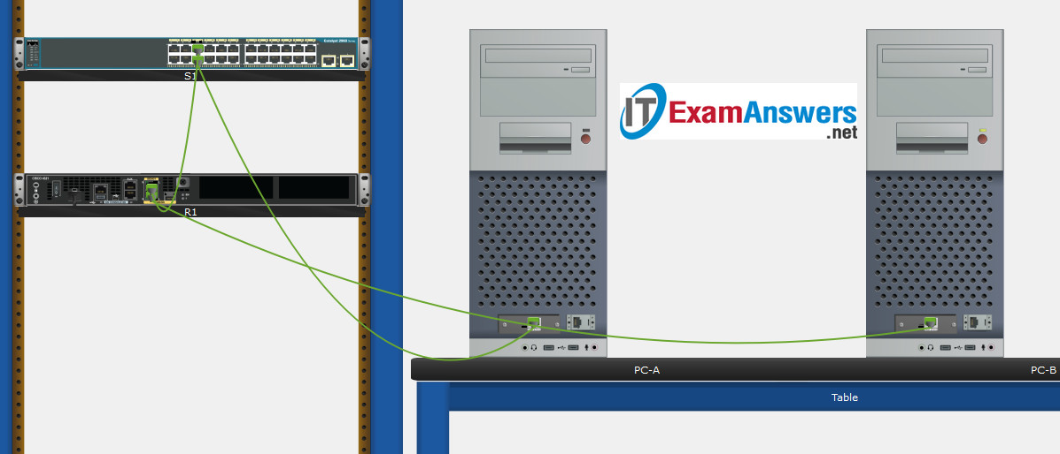
Turn-on PCs and Router R1
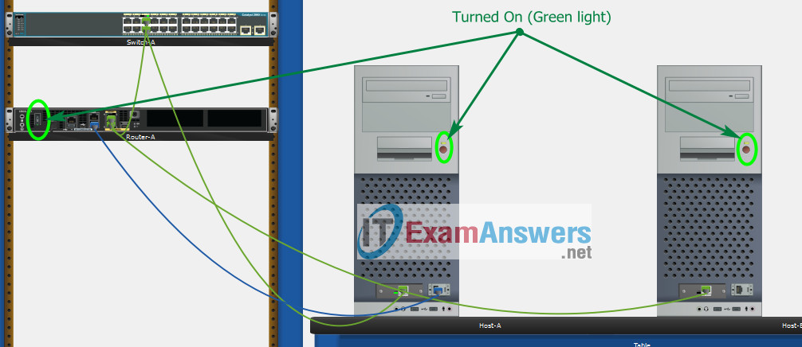

Part 2: Develop an IP Addressing Scheme
Item | Requirements | IPv4 Address
Network Address | 192.168.10.0/24
LAN 1 subnet host requirements | 100 | 192.168.10.0/25  SM: 255.255.255.128
LAN 2 subnet host requirements | 50 | 192.168.10.128/26  SM: 255.255.255.192
R1 G0/0/1 | First host address in LAN 1 subnet | 192.168.10.1
R1 G0/0/0 | First host address in LAN 2 subnet | 192.168.10.129
S1 SVI | Second host address in LAN 1 subnet | 192.168.10.2
PC-A | Last host address in LAN 1 subnet | 192.168.10.126
PC-B | Last host address in LAN 2 subnet | 192.168.10.190
Using line console to connect PC-A and Router
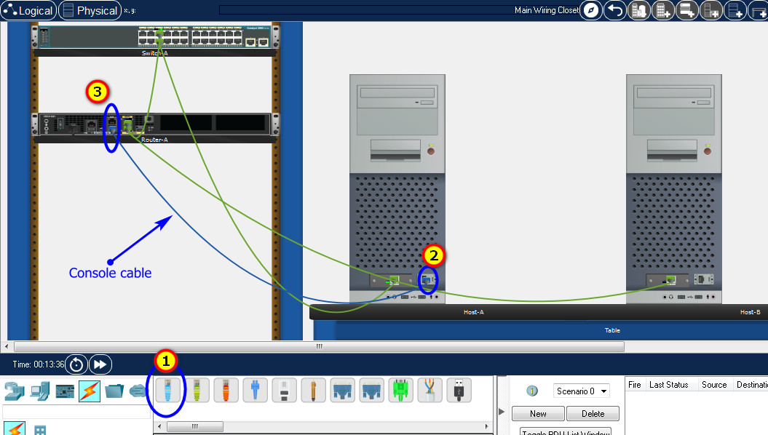
Click to PC-A --> Terminal app --> click OK
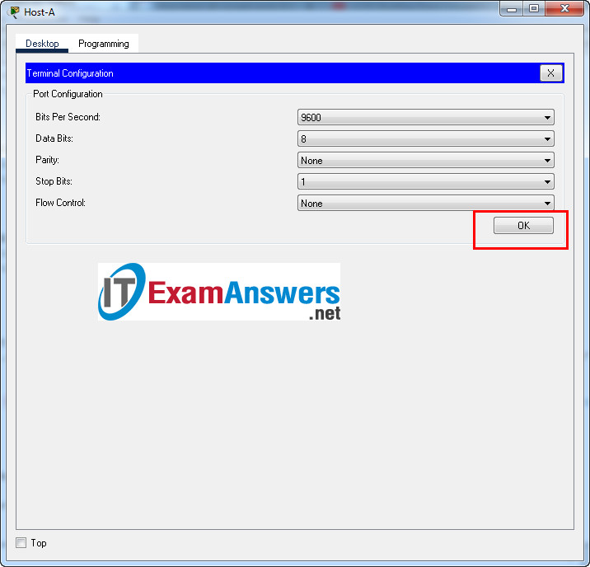
Router R1 configuration script
enable
configure terminal
no ip domain-lookup
hostname R1
banner motd #Unauthorized access to this device is prohibited!#

interface g0/0/0
description Connect to Subnet B
ip address 192.168.10.129 255.255.255.192
no shutdown
exit

interface g0/0/1
description Connect to Subnet A
ip address 192.168.10.1 255.255.255.128
no shutdown
exit

enable secret DontTellAnyone
service password-encryption
security passwords min-length 10

ip domain-name netsec.com
username netadmin secret Ci$co12345

line console 0
password C@nsPassw!
login
exit

line vty 0 15
transport input ssh
login local
exit

crypto key generate rsa
1024
exit
copy running-config startup-config

Configuration for Switch S1
Then, using Console cable to connect PC-B and Switch
To show Console port on Switch, Right click Switch --> Inspect Rear --> Console port
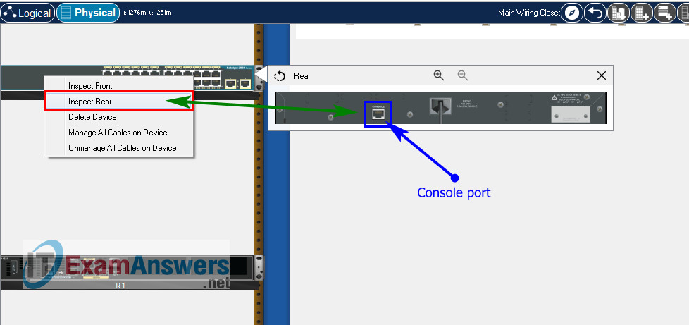
Switch S1 configuration script
enable
configure terminal
no ip domain-lookup
hostname S1
banner motd #Unauthorized access to this device is prohibited!#

interface vlan 1
description Switch Subnet A
ip address 192.168.10.2 255.255.255.128
no shutdown
exit

ip default-gateway 192.168.10.1

enable secret DontTellAnyone
service password-encryption

ip domain-name netsec.com
username netadmin secret Ci$co12345

line console 0
password C@nsPassw!
login
exit

line vty 0 15
transport input ssh
login local
exit

crypto key generate rsa
1024

int range f0/1 - 4, f0/7 - 24, g0/1 - 2
description Unused switch ports
shutdown

end
copy running-config startup-config

Part 5: Configure the Hosts and Verify Connectivity
On PCs, go to Desktop tab --> IP Configuration menu
PC-A Network Configuration
IPv4 Address | 192.168.10.126
Subnet Mask | 255.255.255.128
IPv4 Default Gateway | 192.168.10.1
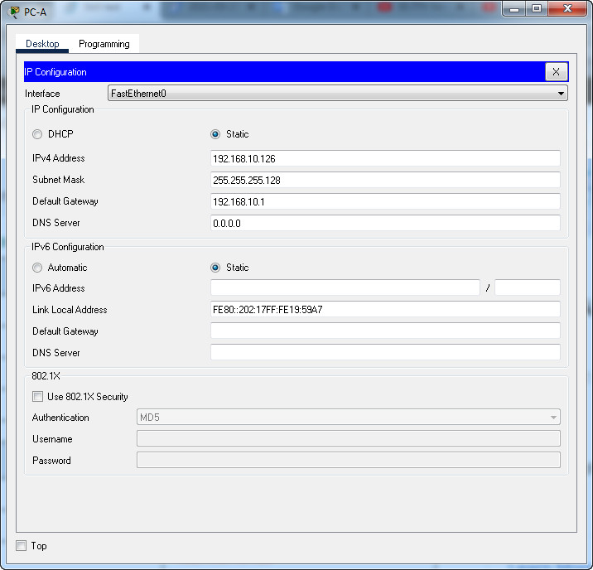
PC-B Network Configuration
IPv4 Address | 192.168.10.190
Subnet Mask | 255.255.255.192
IPv4 Default Gateway | 192.168.10.129
